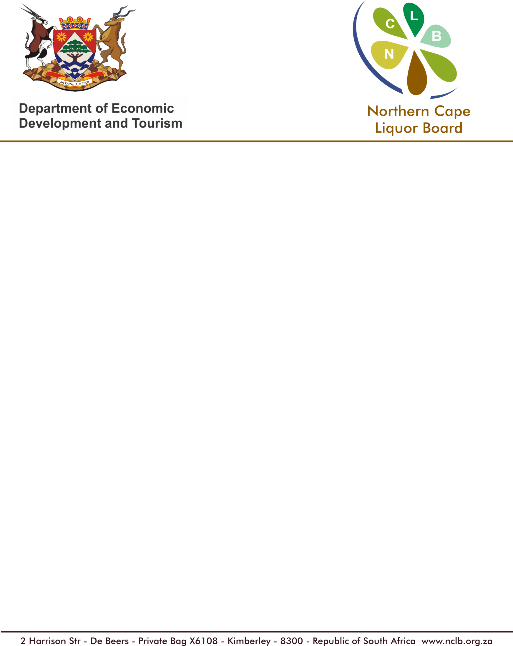

APPLICATION IN TERMS OF SECTION 20 OF THE NORTHERN CAPE LIQUOR ACT

CHECK LIST

REQUIREMENT | AVAILABLE |  | NOT AVAILABLE
Comprehensive written representation in support of the application [Section 20(1)(a)]
Approved plans of the premises [Section 20(1)(b)]
Description or Photos of the premises [Section 20(1)(c)]
Proof of notices required [Section 20(1)(d)]
Proof of payment of prescribed fee [Section 20(1)(f)]
Land usage restriction [Section 20(1)(g)]
Applicants contribution in combating alcohol abuse [Section 20(1)(h)]
Report from the Police Report
Report from the Municipality
Form 1 complete | YES |  | NO

COMMENTS / REMARKS CHECKED BY:______________________________

..........................................................................................................................................................................

..........................................................................................................................................................................

..........................................................................................................................................................................

..........................................................................................................................................................................

..........................................................................................................................................................................

..........................................................................................................................................................................

..........................................................................................................................................................................

