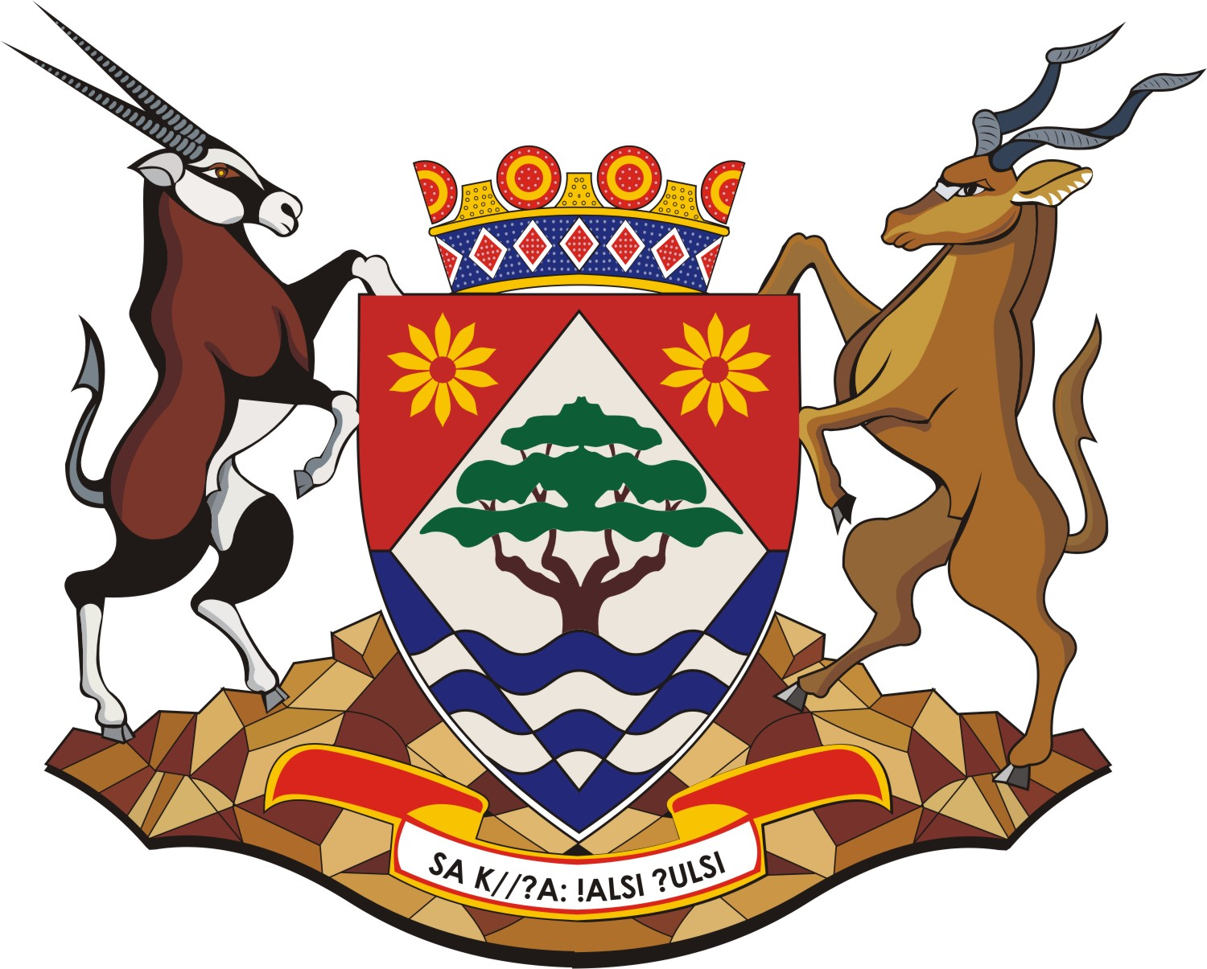 | NORTHERN CAPE OFFICE OF THE PREMIER
INTERNSHIP PROGRAMME

The Northern Cape Office of the Premier seeks to help unemployed graduates to gain workplace experience in the field of work that they have studied by offering an Internship Programme for 24 months for the following area/field:

Directorate | Qualification required | Reference No.
Batho Pele | Diploma or Degree in Social Science | B&P/11/2021
Information Communication Technology | Diploma or Degree in Information Technology | ICT/11/2021

REQUIREMENTS:

Applicants must be unemployed South African citizens and residents of the Northern Cape. Applicants must be between the age of 18 to 35 and be in possession of the qualification mentioned above. Applicants who have not yet received their qualifications must provide academic transcripts or letters confirming that they have completed their studies.

HOW TO APPLY:

The Northern Cape Provincial Government is an equal opportunity, affirmative action employer, and women and persons with disabilities are encouraged to apply. During appointment the Office of the Premier will consider its Employment Equity Plan. Applications must be submitted on new Z83 form which is effective from 01 January 2021, obtained from any Public Service Department and should be accompanied by copies of qualifications, identity document and drivers licence and any other relevant documents. Such copies need not be certified when applying for a post. The communication from the HR of the department regarding the requirements for certified documents will be limited to short listed candidates. Therefore only short listed candidates for an Internship will be required to submit certified documents on or before the day of the interview following communication from HR. Applicants must also submit a comprehensive CV in order to be considered, failure to comply with these instructions will disqualify applications from being processed. It is the applicant’s responsibility to have foreign qualifications evaluated by the South African Qualification Authority (SAQA). All applicants should please note that correspondence will be limited to successful candidates only, if you have not been contacted within six (6) weeks after the closing date of this advertisements, please accept that your application was unsuccessful.

Please forward the applications for the Internship quoting the relevant reference number to: Senior Manager, Human Resources Administration, Private Bag X5016, Kimberley, 8300 or hand deliver at JW Sauer Building, Office of the Premier, Ground Floor (Security), for Attention: Mrs. R. Booysen

Successful candidates will be required to enter into a 24 months’ internship contract and will receive a monthly stipend of R6 174, 96 as per DPSA Interns remuneration schedule.

CLOSING DATE: 03 December 2021

