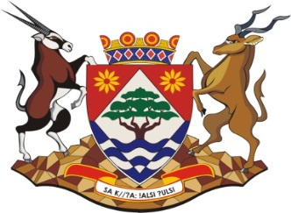

OFFICE OF THE PREMIER
WEB PUBLICATION
REGISTER OF BIDS RECEIVED
BID NO: PO 01/04/2023
Request for proposal to appoint a capable service provider for the overall administration and project management of the Northern Cape Provincial Government Skills Development Project
NO | COMPANY NAME
1 | DORODOX TRAINING MANAGEMENT
2 | EVERS EXCELLENCE MANAGEMENT CONUSULTING
3 | AMBRITANI CONSULTING
4 | KARABO STRATEGIC ADVISORY SERVICE
5 | SOUTH HILL TRADING t/a HOTEL 164

