NORTHERN CAPE
DEPARTMENT OF ECONOMIC AFFAIRS
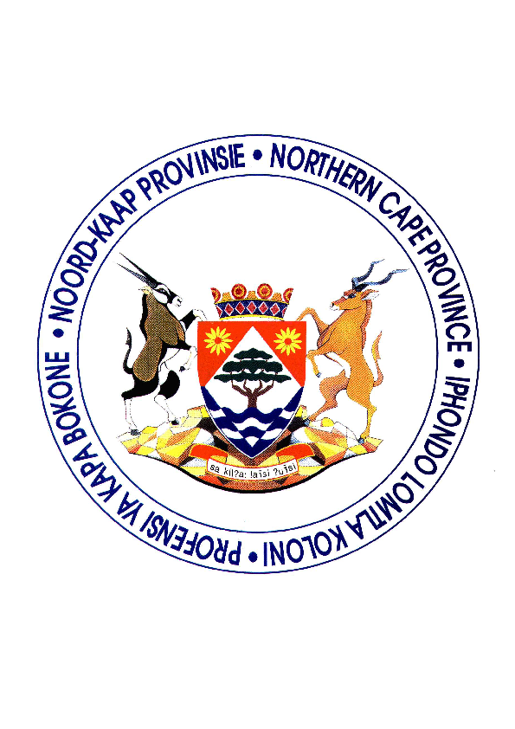
(DRAFT)
CONSULTATION STRATEGY

- Preamble:

The purpose of this document is to set a framework for consultation with regard to policies and strategies that requires consultation with staff. This will include Employment Equity issues as well as all documents that need the inputs of staff members and trade union representatives.

- Legislative Framework:

Employment Equity Act, 1998
Labour Relations Act, 1995
Dispute resolutions of the Department of Economic Affairs

- Mandates:

The Employment Equity Act, Section 16, requires the employer to take reasonable steps to consult employees and/or representatives and attempt to reach agreement on matters such as the analysis, preparation and implementation of the Employment Equity plan and the Employment Equity report. It also requires that the employer disclose all relevant information required by employees and/or representatives allowing effective consultation.

In addition, many policies that is developed within the Department, affects the daily conduct of staff. Consultation with regard to the contents of the policies is necessary. It should however be consultation and not negotiation, where inputs will only be effected as long as it is within legal framework and within the objectives of the Department.

- The consultation strategy:

The Department of Economic Affairs is committed to the consultation principles set out in terms of the Employment Equity Act and the Labour Relations Act. The strategy that the Department will adopt to ensure that all staff is consulted with consists of 3 elements.

- The Consultative Forum

The consultative forum will consist of democratically elected staff members and trade union representatives from the unions with representation in the Department.

Before the election of the consultative forum, the manager assigned with Employment Equity responsibilities will arrange an information session with all staff members on a programme level.

During the information sessions a date will be provided for the relevant trade unions to submit the names of their relevant representatives. These representatives will then assist the Employment Equity Manager during the counting of the votes after the democratic election of the forum members.

The elected forum members will be notified in writing and will then form the Employment Equity forum.

- General Staff Meetings

Although all occupational levels will be represented in the Consultative Forum, the Department may still provide regular updates during general staff meetings.

- Line managers

Line managers have a critical role to play to ensure that staff fully understands the Department’s Employment Equity Plan and any policies that may affect the daily conduct of staff members.

Line managers are requested to ensure feedback from SMAC and other management meetings as well as written correspondence with regard to any policy of plan of the Department, with specific reference to the Employment Equity plan and any policies of the Department affecting the staff members.

- The Consultative Forum

  - Terms of reference

The consultative forum will consult on the following:

    - The conduct of the analysis referred to in section 19 of the Employment Equity Act.
    - The preparation and implementation of the Employment Equity plan referred to in section 20 of the Employment Equity Act.
    - The report referred to in section 21 of the Employment Equity Act.
    - Any policy that is drafted and affects the conduct and/or service benefits of staff members in the Department of Economic Affairs.

The consultative forum will further have the responsibility to give feedback to the staff members that they represent.

  - Composition of consultation forum

The Department of Economic Affairs will as employer representatives have the following members on the forum:

    - A member from the Departmental Accounting Unit that will be able to respond on any financial and budgetary issues
    - The Skills Development Facilitator
    - The Supply Chain Manager
    - A member from the Communication Unit.

The Consultative forum will be represented by one of each of the designated groups in terms of the Employment Equity Act as well as the non-designated group. It will also be representative of all occupational levels in the Department. If after the democratic election, it is found that an occupational level is not represented, such a member will be co-opted to the forum by the elected forum members.

The groups that needs representation in terms of the Act are as follows:

African Male
African Female
Coloured Male
Coloured Female
Indian Male
Indian Female
White Female
White Male
Disabled

The Consultative forum will serve for the duration of the period of the Employment Equity Plan, which will be for a minimum of three years and a maximum of five years. If a member of the forum leave the Department, the constituency that he/she represented should elect a new member and should submit the name of such a member to the Chairperson of the forum.

- Procedures for Consultation Forum Meetings:

  - Pre-meeting procedures

    - The designated manager assigned with the responsibility of Employment Equity in the Department will be the Chairperson.
    - A deputy chairperson and a secretary are to be elected at the forum.
    - The Chairperson together with the elected secretariat will manage all meetings incl. agendas, minutes and invitations.
    - A formal agenda will be agreed on before each meeting
    - Proposals prior to meetings will be circulated to members five working days prior to the meeting, unless circumstances dictate otherwise.
    - Only written submissions for input will be accepted and debate is to be restricted to items tabled.
    - Chairpersons will have to have a formal and agreed method for handling disputes.
    - Chairpersons will have to apply consistent rules to determine when consensus or agreement has been achieved.

  - Rules for conducting meetings

    - Bi-monthly meetings to be held
    - Have a clear objective and goals as to what is to be achieved.
    - Agenda should be carefully drawn up and should be circulated to members before the meeting
    - Start all meetings on time
    - Stick to agenda
    - Only allow discussion that is relevant to the point being discussed
    - Discussion and comments to go through the chair only
    - Allow each speaker to make his point without interruption
    - Ensure all decisions are properly noted and recorded
    - Circulate the minutes to all attendees with no longer than one week after the meeting

  - Dispute resolution processes

    - The internal dispute resolution of the Department should be utilized for any disputes that may occur within the forum.

  - Guidelines for achieving consensus

    - A simple majority will be accepted
    - If a deadlock is to occur issues are to be broken down into more points and an attempt to achieve consensus on as many of these sub-issues as possible
    - It is crucial that the process is seen to be legitimate and that every effort has been made to attempt to reach consensus
    - The employer ultimately has the responsibility for compliance and must move forward provided reasonable steps have been taken to reach agreement, after taking into account the views expressed in the consultation process

  - Post meeting procedures

    - Minutes should be kept of all meetings
    - These minutes should be distributed to all committee members and place on the notice board of the Department
    - The communication officer that forms part of the forum should assist with internal communication regarding all Employment Equity and policy issues
    - Attendance registers should be kept of all meetings

