

The aim of this programme is to promote and raise awareness of entrepreneurship, targeting Youth,

Women and Persons with Disability throughout the Northern Cape Province.

**Target**

* Existing Youth, Women and Persons with Disability owned enterprises
* Informal Businesses in Rural and Township areas
* Start-ups

**Qualifying Criteria**

* Owner must have a valid SA identification document.
* Registered as a legal entity (CIPC, SARS, UIF, etc.) (Formal and Existing enterprises)
* Willing to submit monthly management reports.
* Municipal trade permits for Informal Business.
* Proof that the business has been trading for at least 6 months. (Existing Enterprises)
* Have a valid business account or willing to open one.
* Operating in a township or rural area.
* Submission of a business plan (Formal enterprises).

**Required Documents to be submitted**

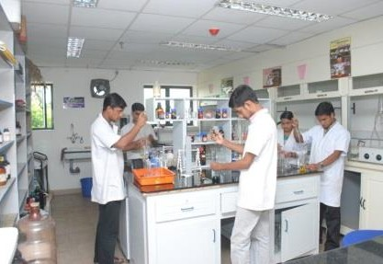

* Identity Document
* Proof of Residence
* CIPC documents (Formal and Existing Enterprises)
* Trade Permit (Informal Enterprises)
* Business Plan (Formal Enterprises